**IAM – Identity and Access Management**

**Policies -** Have permission which says what can be read/write/delete

**Users -** Users can be created and associated to policies

**Groups –** N number of users inside a group and attached to a policy

**Roles –** If an application running in an instance need to read/write from an object (S3/DyanmoDB etc) those access details can be given in role. We have to attach the role to the resource which runs the custom application

**IAM API Key –** It checks user or role and an associated policy and grant permission to objects (S3/DynamoDB etc)

**IAM** – For implementing security on cloud

**IAM -** Is for creating users/group and assign IAM policy (this will have granted permission to the users)

**IAM Users/roles/permission**

IAM is not region oriented. It is global

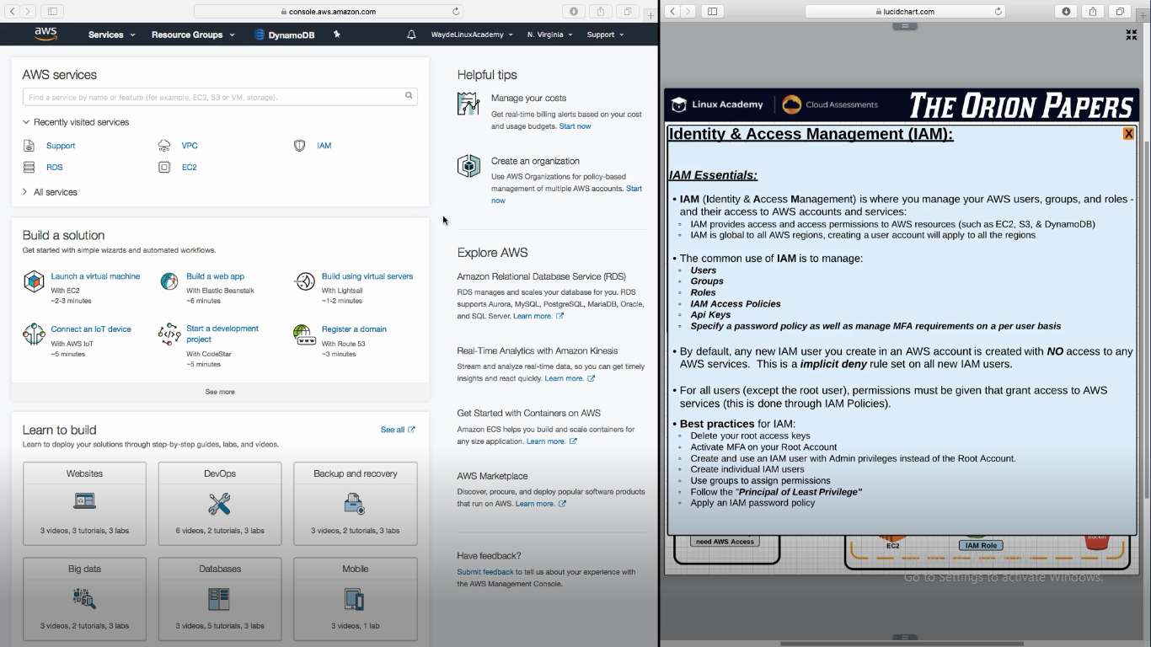

We can create n number of IAM Users. It is free

If user is going to access AWS via console, grant console access password

If user is going to access AWS via CLI, AWS SDK create API Keys

IAM Access is to be given to **users, group or role** and access is controlled by **permission policies**

If a new user is created and if we don’t assign a policy to the user, by default every access to a resource will be denied

Click the user account inverted triangle, and it will get below pop up page

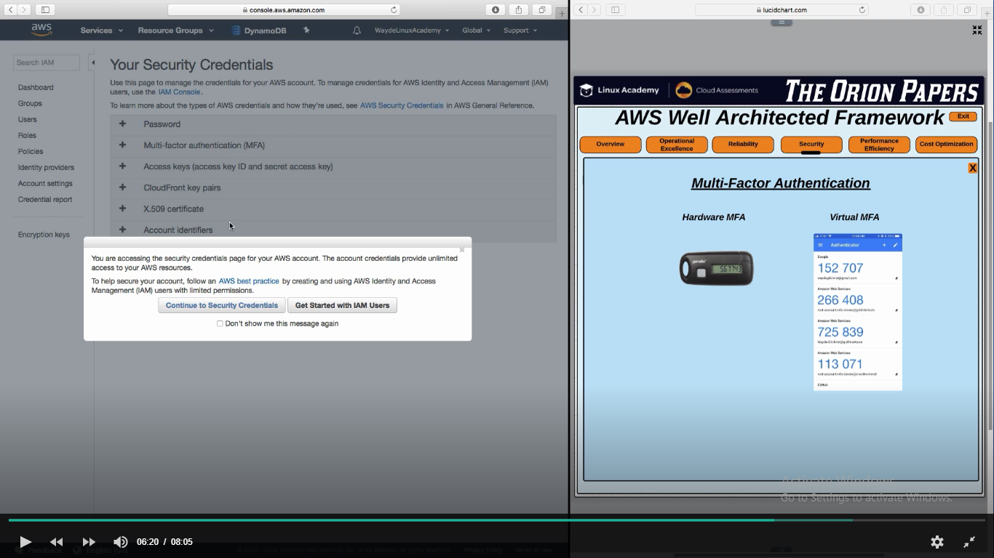

**IAM User** – Individual User

**IAM Group** – Bunch of users who will have same policy

**IAM Policy** -   
Instead of creating 50 individual users and assigning policy to each of the users, create a IAM policy and assign it to the users

**IAM Role** – Applications access to AWS Services

If my custom application want to store/retreive with a data in S3 bucket, we can assodicate the resource running in application code with a IAM Role. That Role will be attached to permission policies that will allow application running to access S3.

AWS Console, AWS CLI, AWS SDK (custom application) all establish connection to AWS Console through API Calls

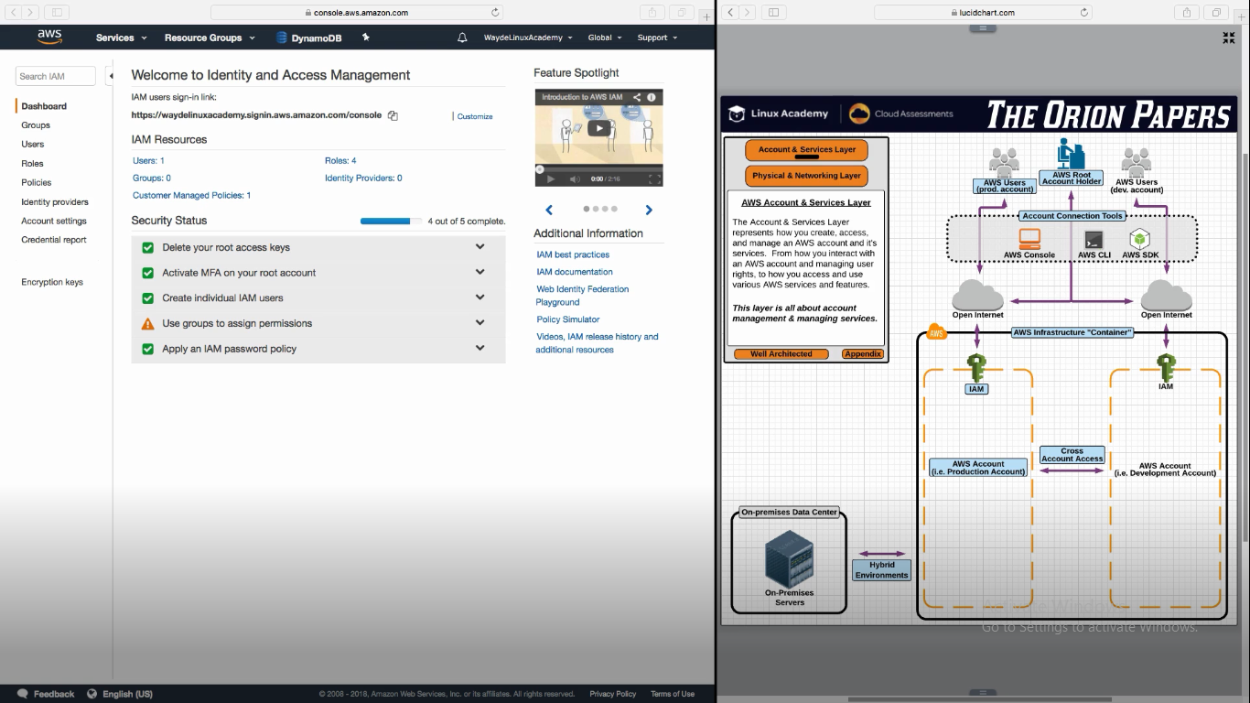

Click on IAM in above image. And it takes to below

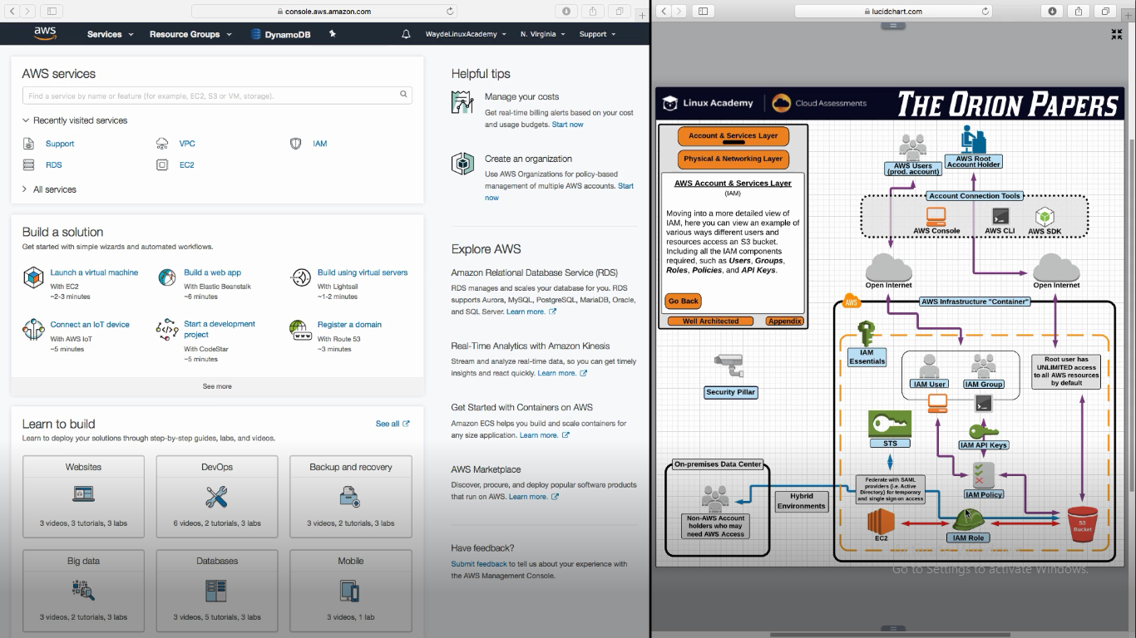

AWS Console -> Security -> IAM

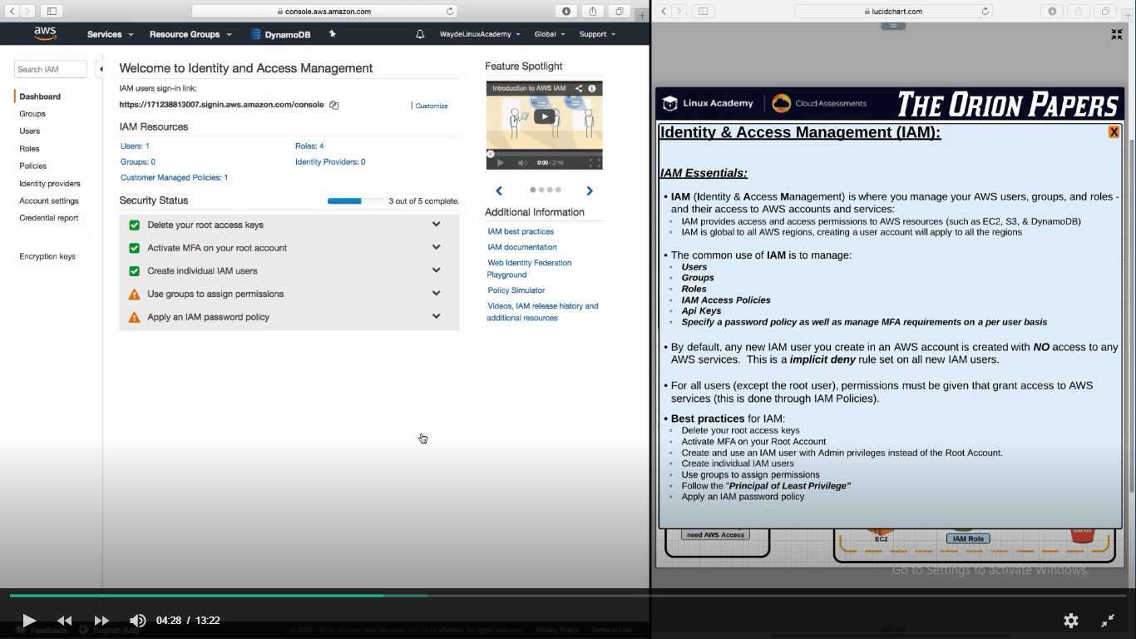

**Identity Providers** – Let users authenticate with LDAP ( such as Active directory) and gain access to AWS by associating Active Directory group with a particular IAM Role

Password restrictions in IAM Password policy

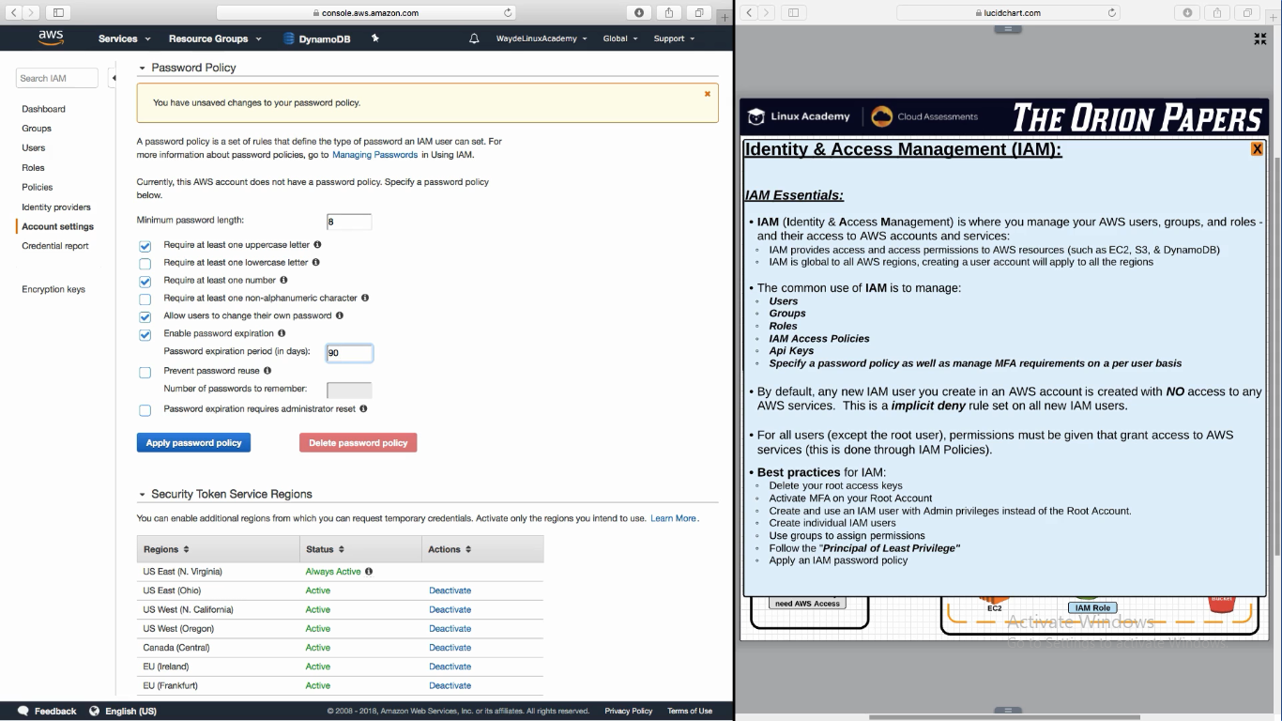

**Policy**

1. One user can have multiple policy associated
2. If one policy allows and another denys, deny will take privilege
3. Policy is nothing but a text document which will have
   1. Effect – Allow or deny
   2. Action – Get, querry, post, retrieve, write, etc
   3. Resource – S3, EC2, DB etc

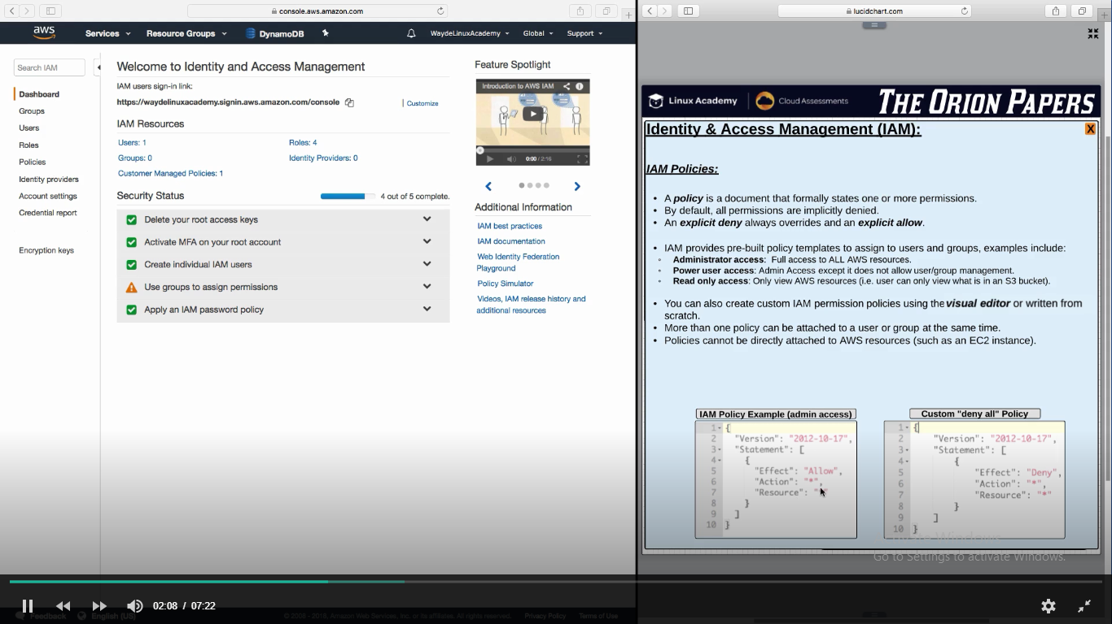

AWS have pre-build policy templates

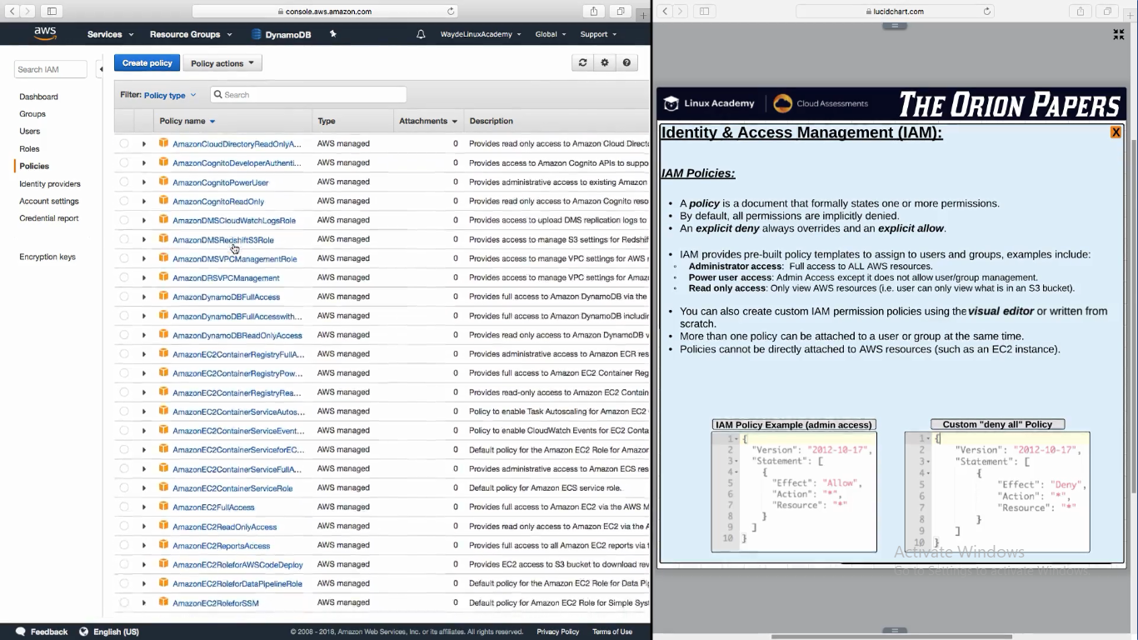

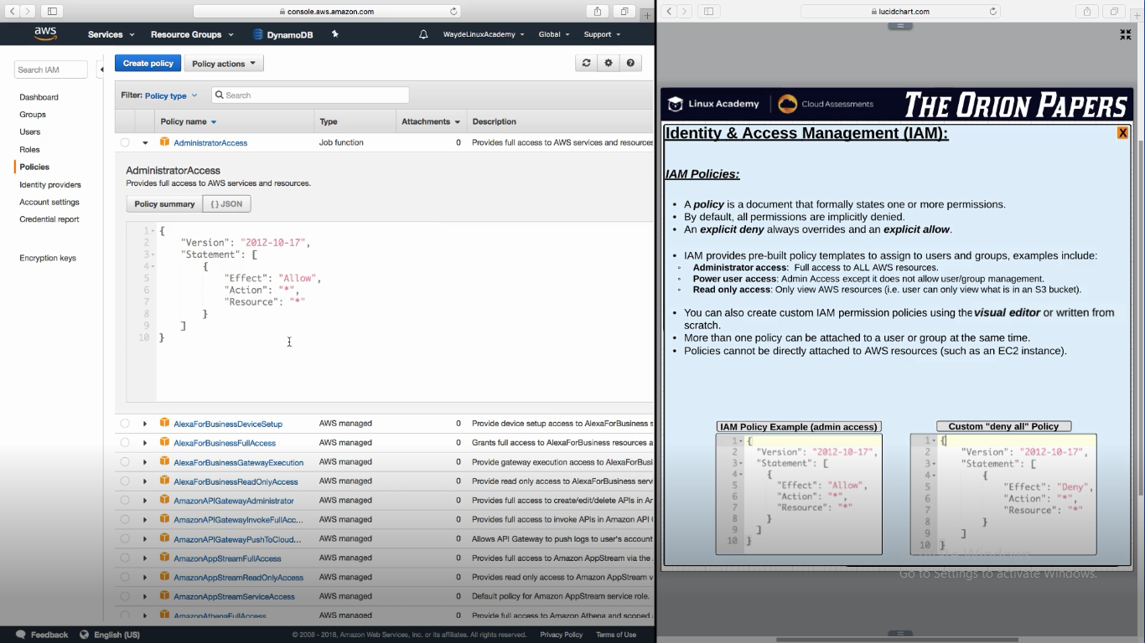

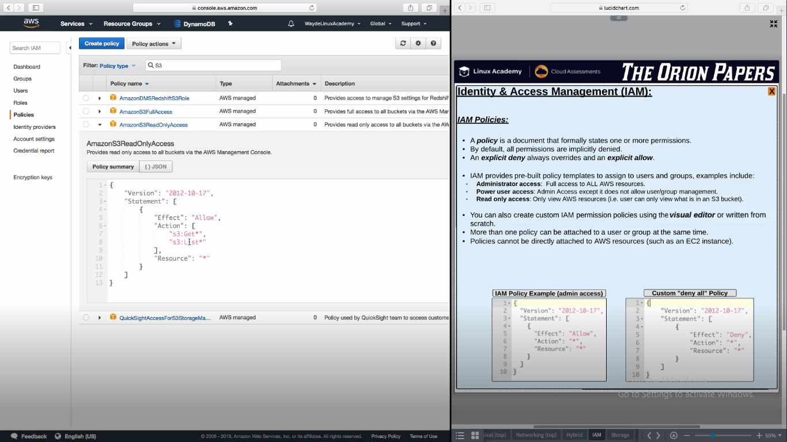

**Creating a new policy**

Each policy will have a amazon resource name

**ARN – Amazon Resource Name**

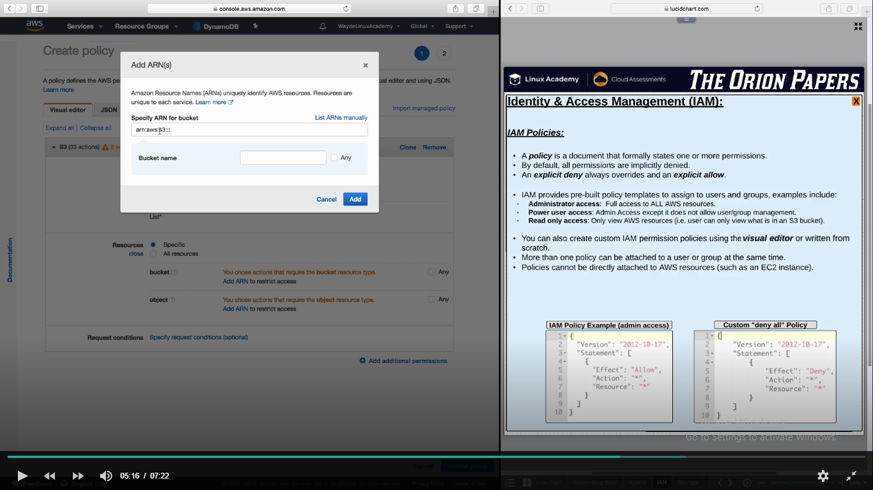

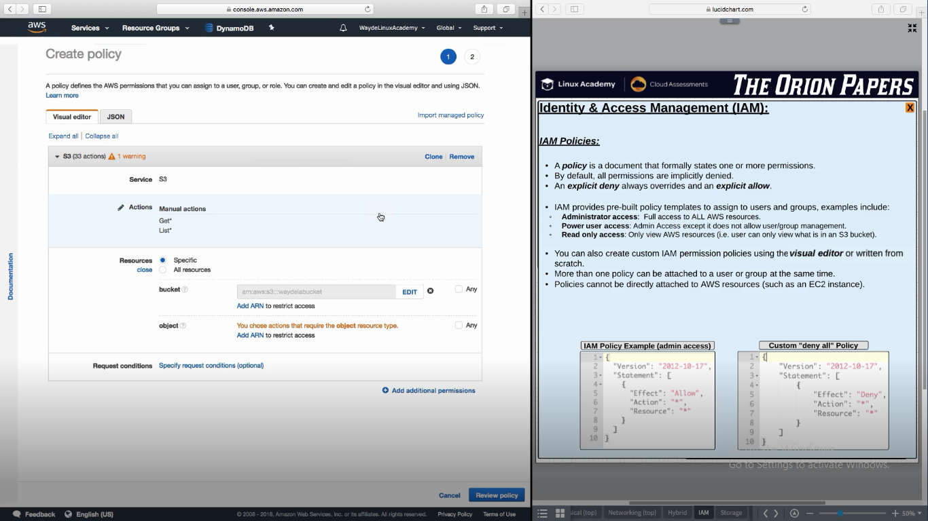

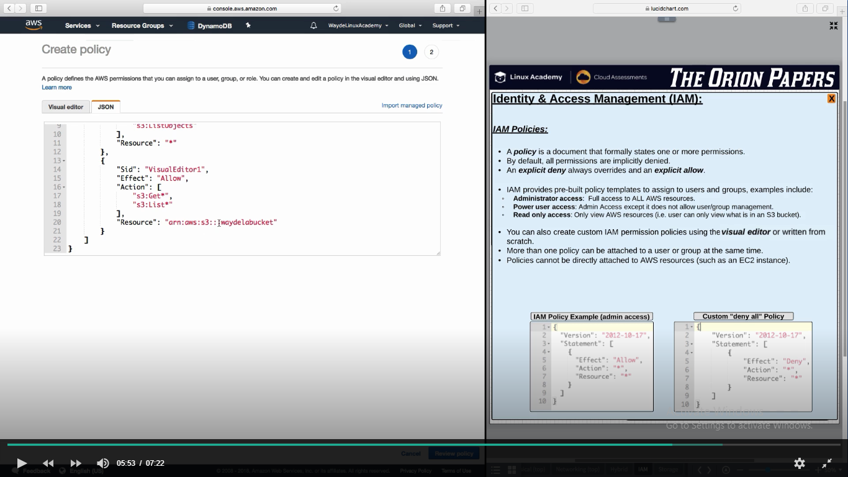

We can add condition to a policy. If the condition is satisfied that policy will be executed

1. Request coming from particular ip
2. Need MFA
3. User have to use only https
4. User have to use tag

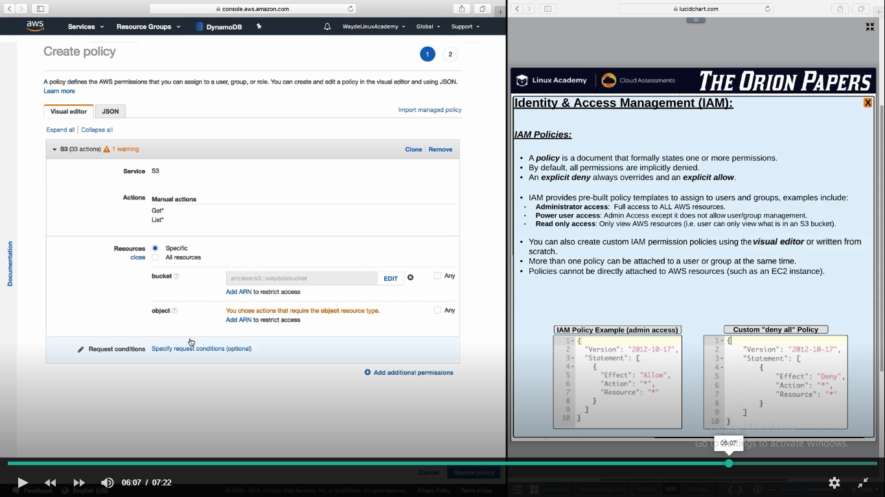

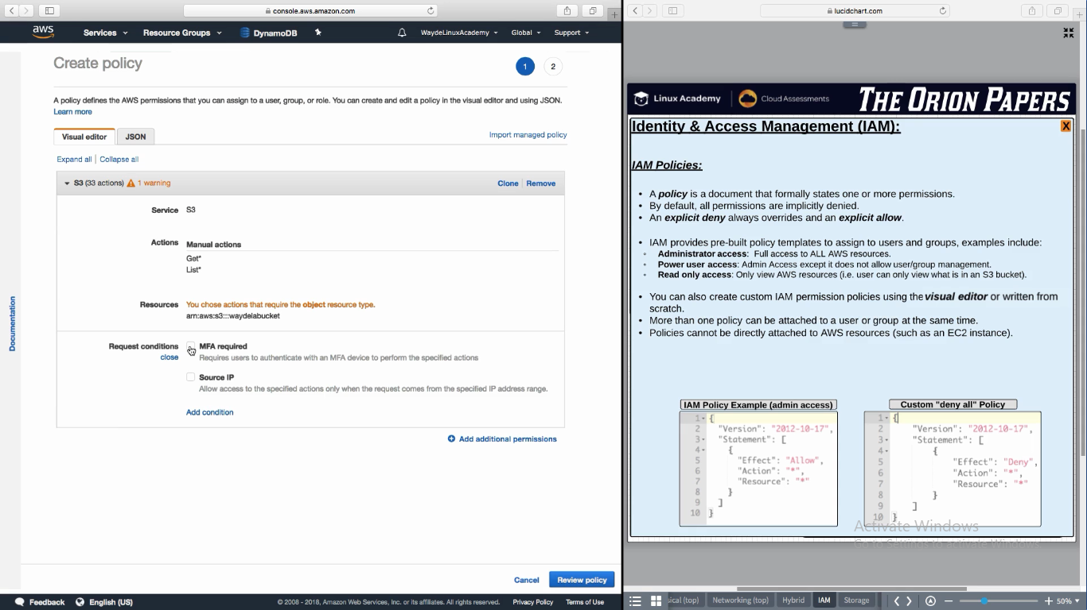

**User**

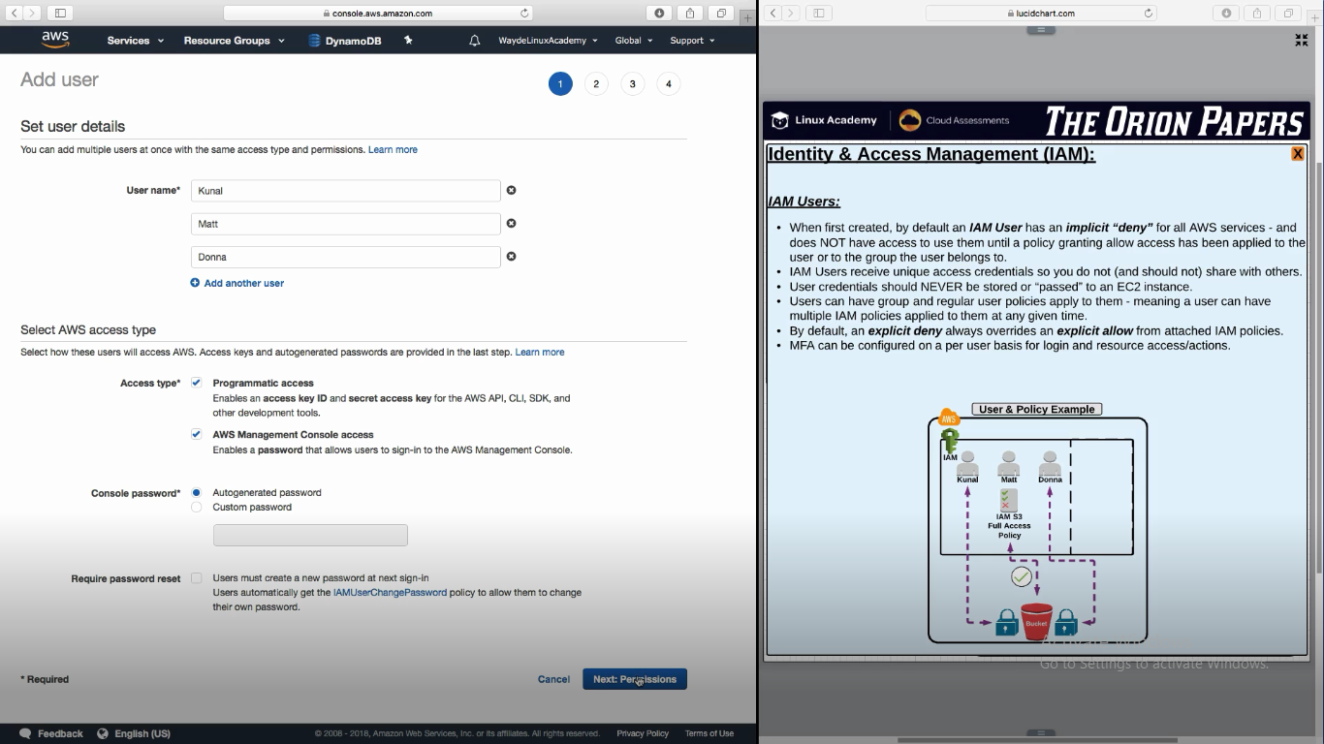

Download and save the file in local. If not we will not get the Secret access key again. If we forget to take it, we have to create a new set of access keys for the user

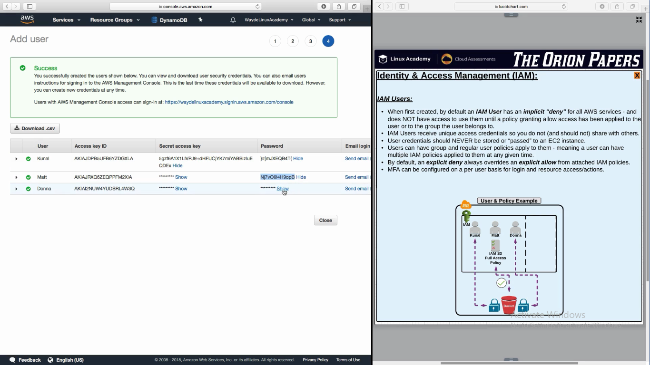

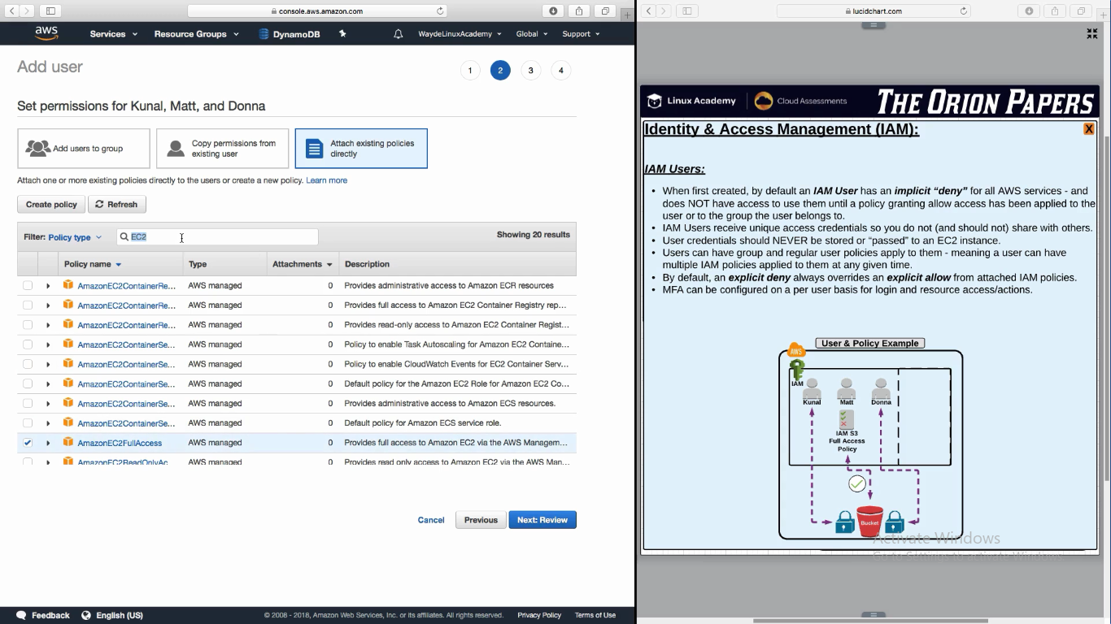

**Inline Policy** – giving a special permission (can be allow or deny) policy for a user

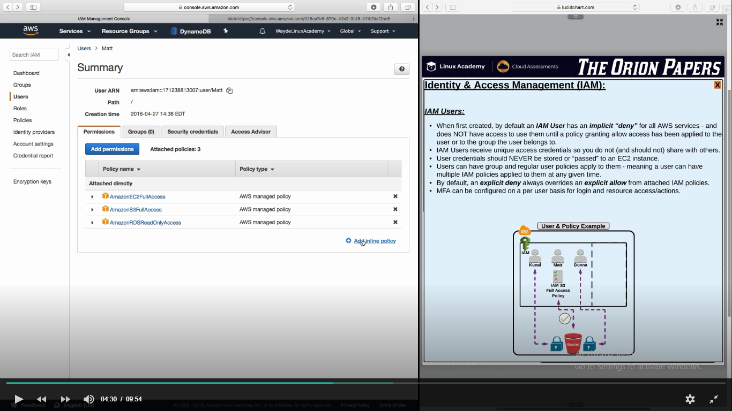

Giving access to one bucket

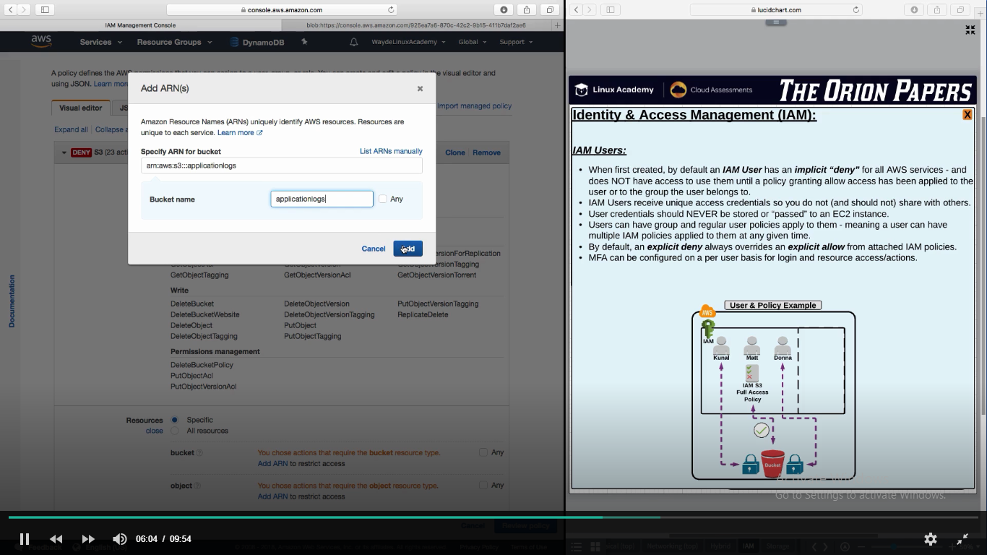

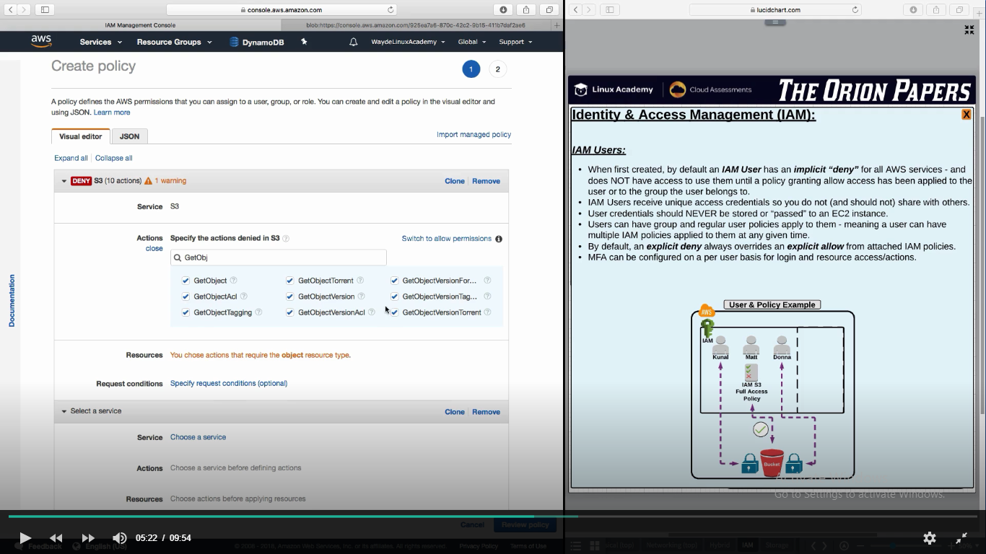

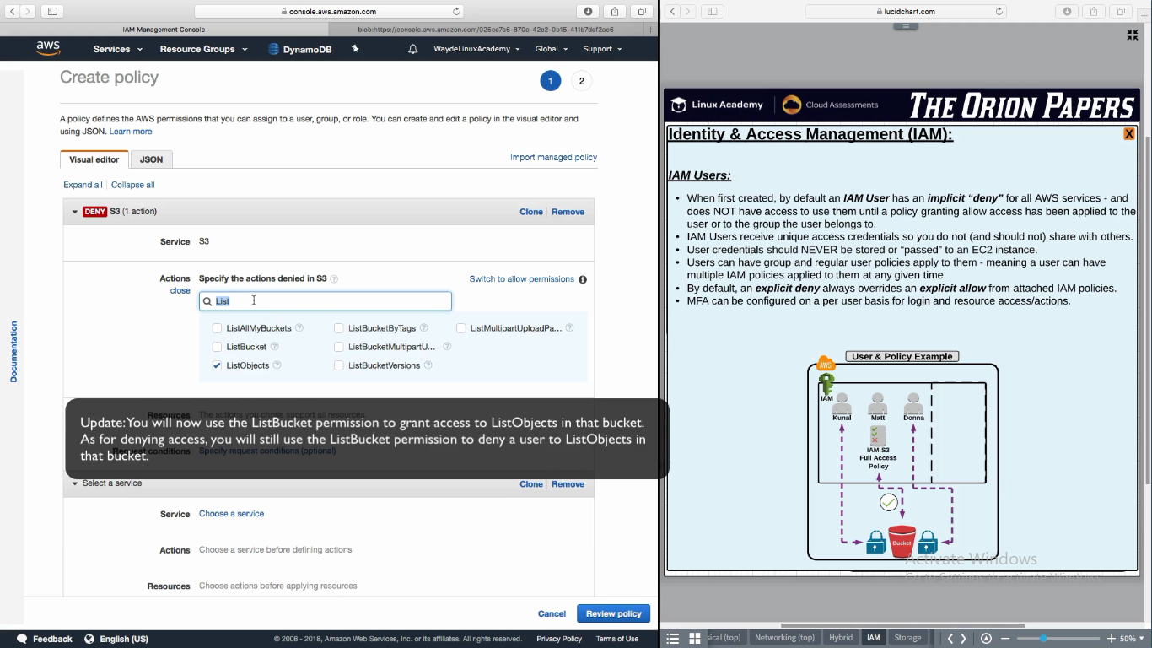

We can create a max of two Access Key ID’s and make one active

Access Keys are not expiable. So we have to create another key and rotate them by making it enable/disable.

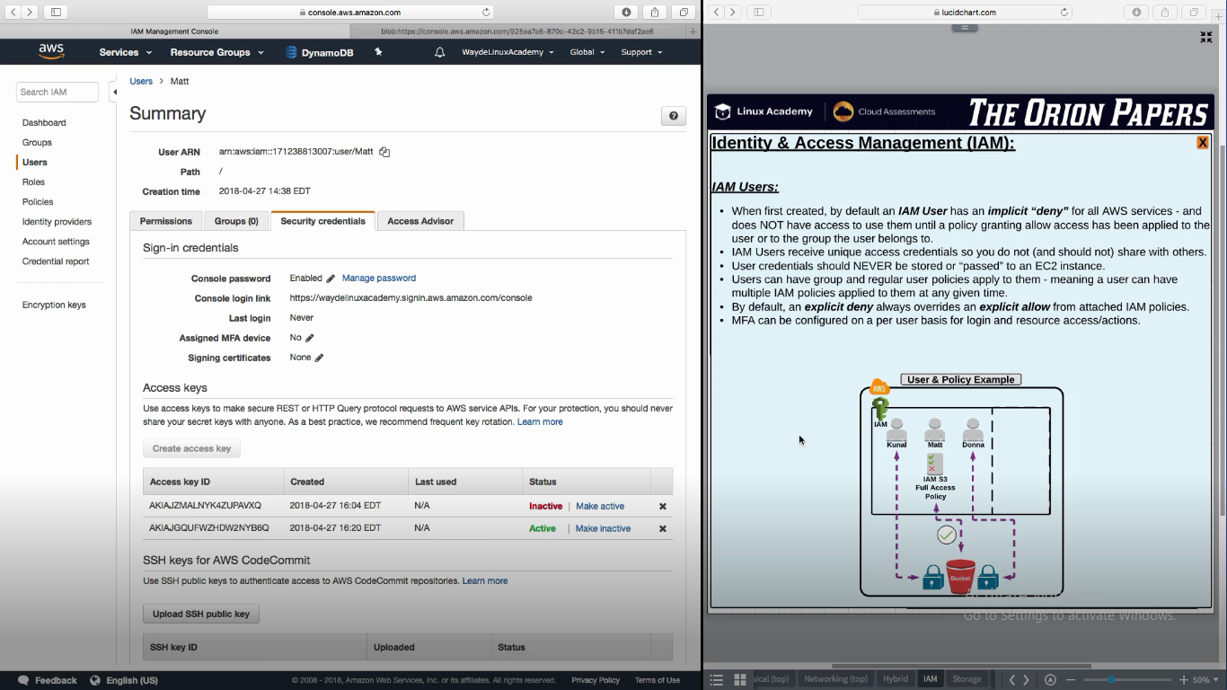

**Groups**

One user can be in multiple group

AWS Console -> IAM -> Group -> Create Group -> Attach Policy

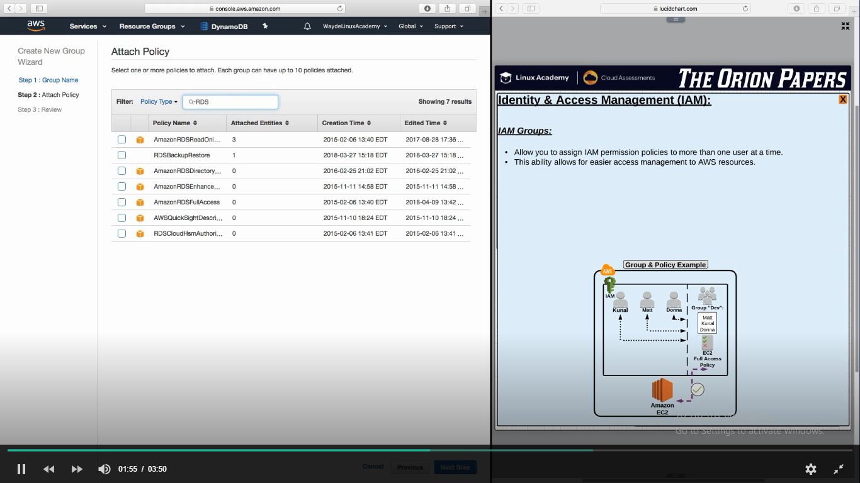

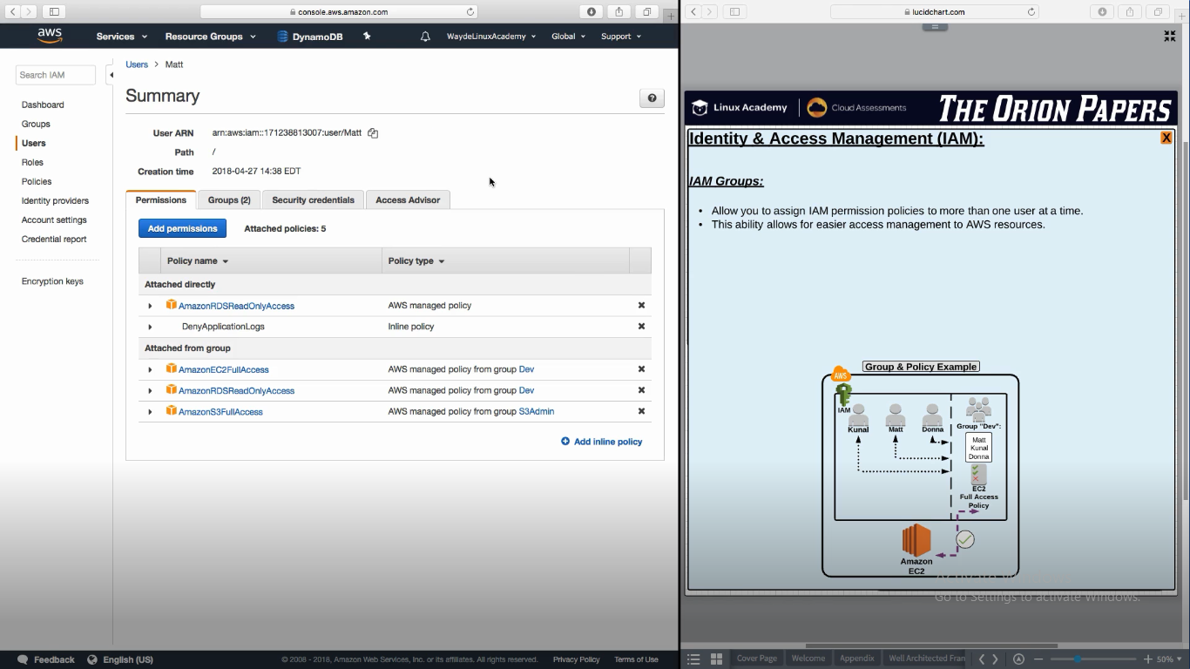

**Roles**

It is a temporary credential – 15 min to 12 hrs to 36 hrs

It can be used by EC2, Lambda, Users etc

When credential is about to expire, application will make a call to STS and get the new credential.

Roles have two things attached to it

IAM Policy – Says which EC2, S3 instance it have access

Trust Policy – Which entity can be have access

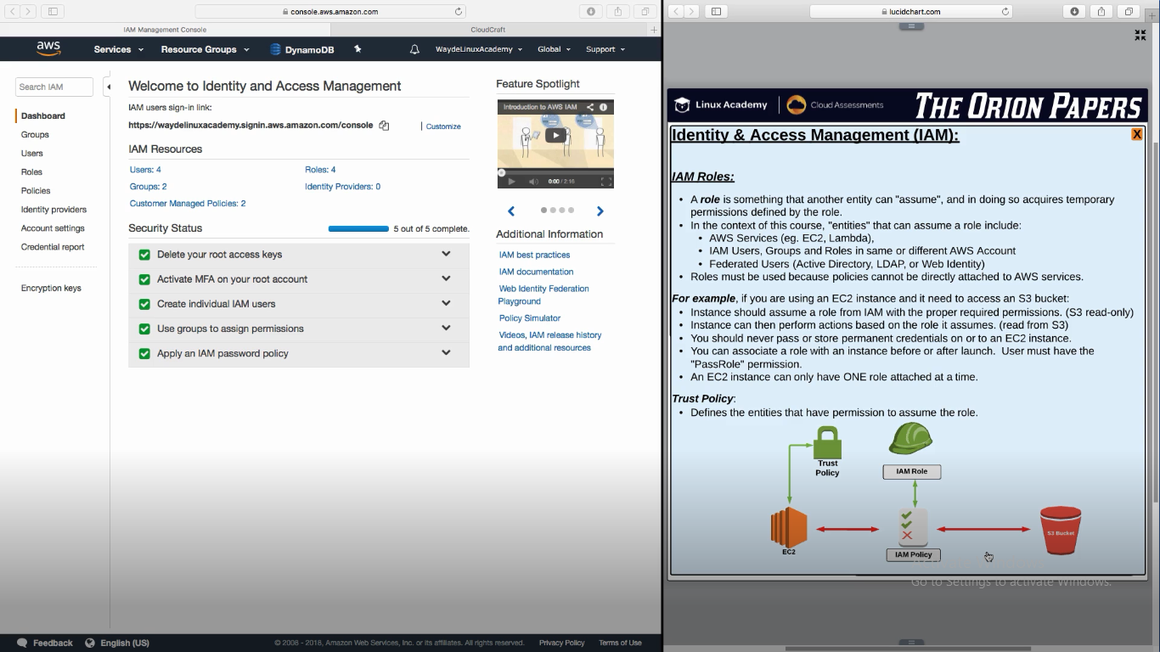

**Scenario**:

If there is an external auditor with their own AWS account, we can add that account in Trust policy for the role we created for them. So that temporarily with their AWS Account they can review our AWS instances

Roles use access key and it comes from service STS

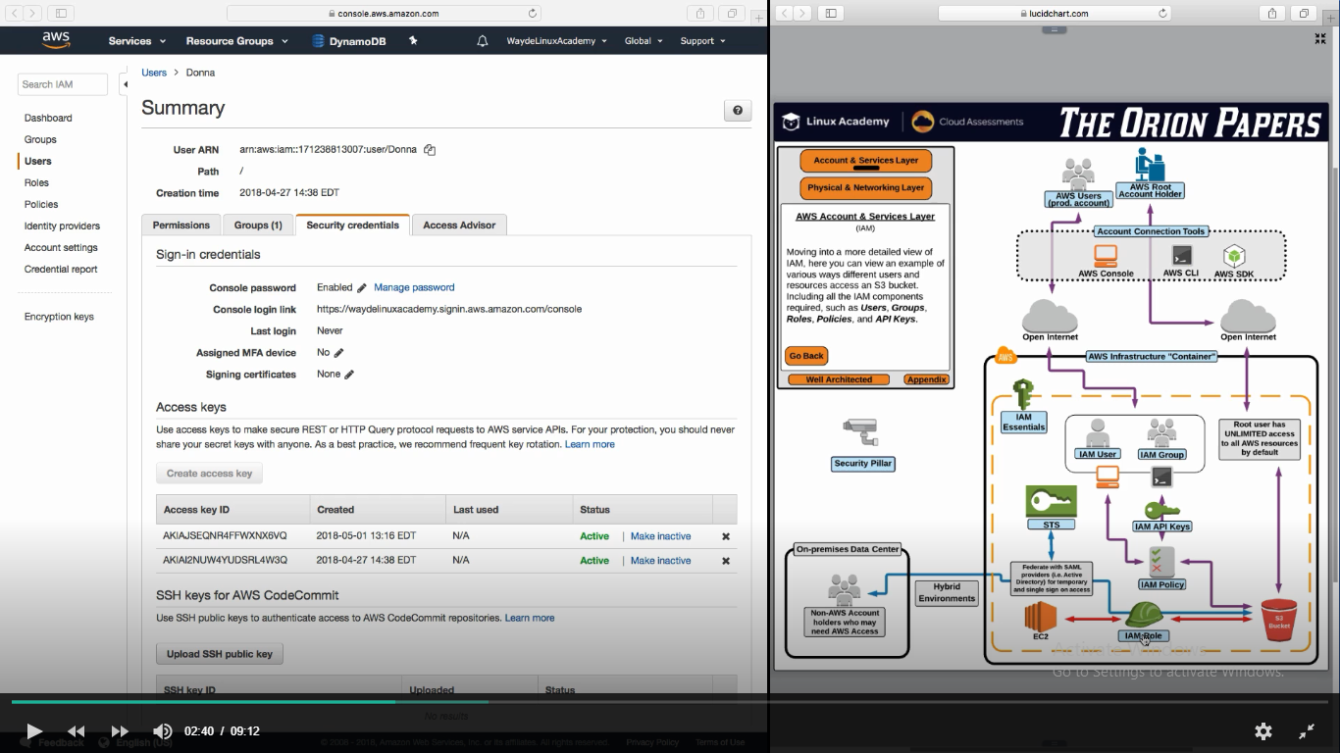

STS – Security Token Service - it have a session token and a expiry time set

Temporary set of access keys

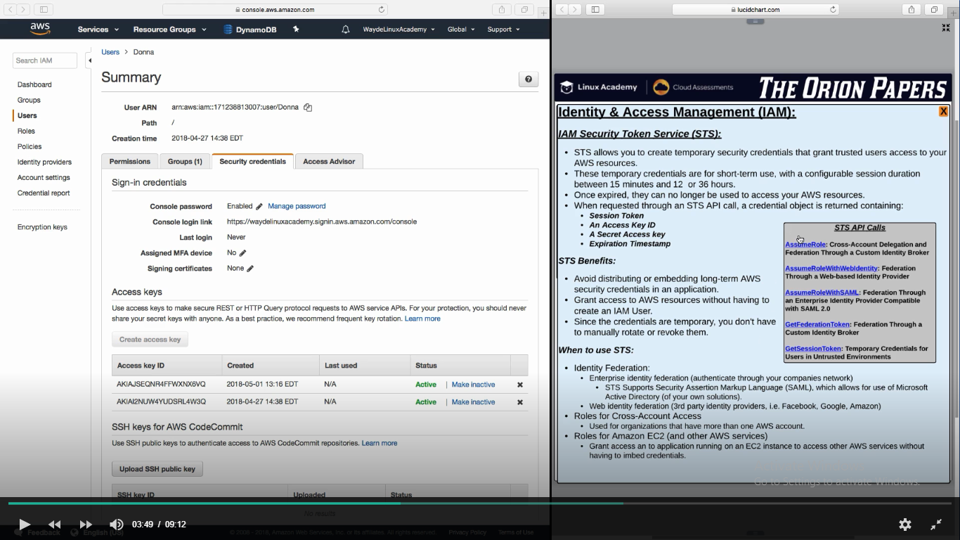

AssumeRole – Get access from a role

AssumeRoleWithWebIdentity – Get access from web based identity provider like google

AssumeRolewithSAML – Get access from LDAP AD Group

GetFederationToken – Take key from a specific user and access as per the policy for the user

GetSessionToken - Take key from a specific user and access as per the policy for the user. It Is in a untrusted environment

**IAM Policy**

A group/user/role can have one m ore more IAM policy attached to it

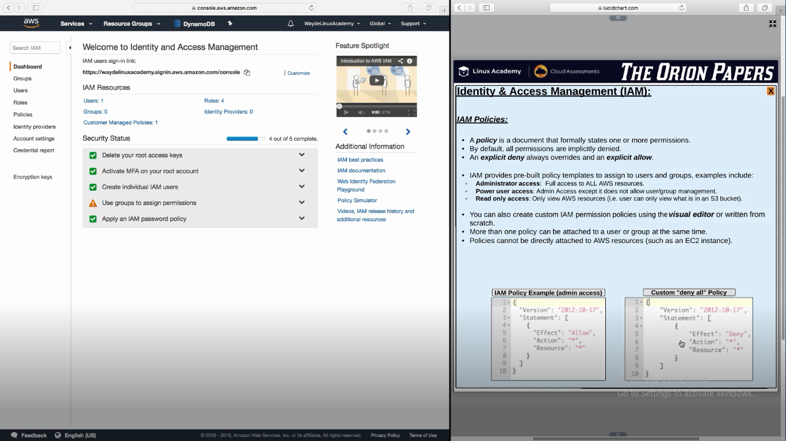

We can put resource (bucket) name here so it will give read only access only for that bucket

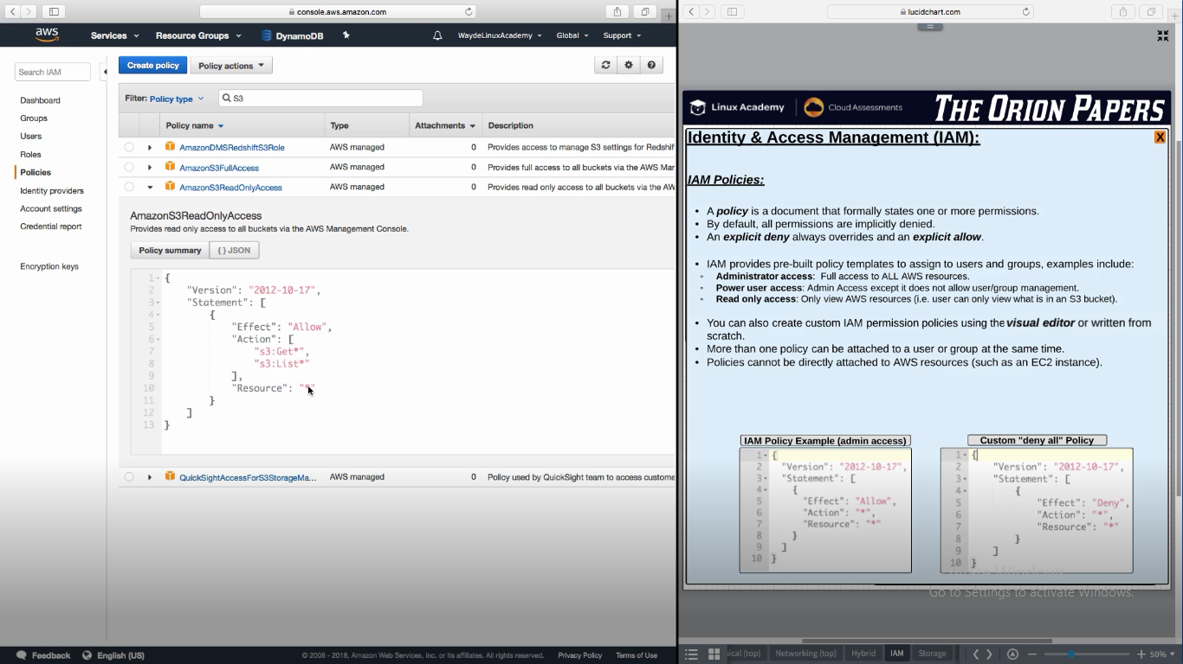

arn:aws:serviceName:Region:accountID:resourcename

arn:aws:iam::1234567:user/keerthi

arn:aws:s3:::buckerName

**References**

API Access Keys are used to grant access to AWS Services programmatically. IAM Users receive permanent access keys, while STS can provide keys with a shorter lifetime.

For more on IAM Access Keys, see: <https://docs.aws.amazon.com/general/latest/gr/aws-sec-cred-types.html#access-keys-and-secret-access-keys>

For more on STS, see: <https://docs.aws.amazon.com/IAM/latest/UserGuide/id_credentials_temp.html>

## Multi-Factor Authentication Applications

<https://aws.amazon.com/iam/details/mfa/>

<https://itunes.apple.com/au/app/google-authenticator/id388497605?mt=8>  
<https://play.google.com/store/apps/details?id=com.google.android.apps.authenticator2&hl=en_AU>  
<https://1password.com/>  
<https://authy.com/>